Supplement and Fitness Shop

Tools Setup

Version <1.0>

Revision History

|  |  |  |  |
| --- | --- | --- | --- |
| **Date** | **Version** | **Description** | **Author** |
| <1/11/2024> | <1.0> | Report tools setup with illustrations | Nguyễn Trần Đức Thiện |
| <3/11/2024> | <1.1> | Complete tools setup | Nguyễn Trần Đức Thiện |
|  |  |  |  |
|  |  |  |  |

Table of Contents

1. Tools 3

Tools Setup

# Tools

**Moodle** for posting and submitting assignments :

**Facebook Group** for general notifications, class discussion, and questions/answers : <https://www.facebook.com/groups/1199416681148298>

**GitHub** for managing source code and related files :

<https://github.com/thienbanho/Fitness-Shop>

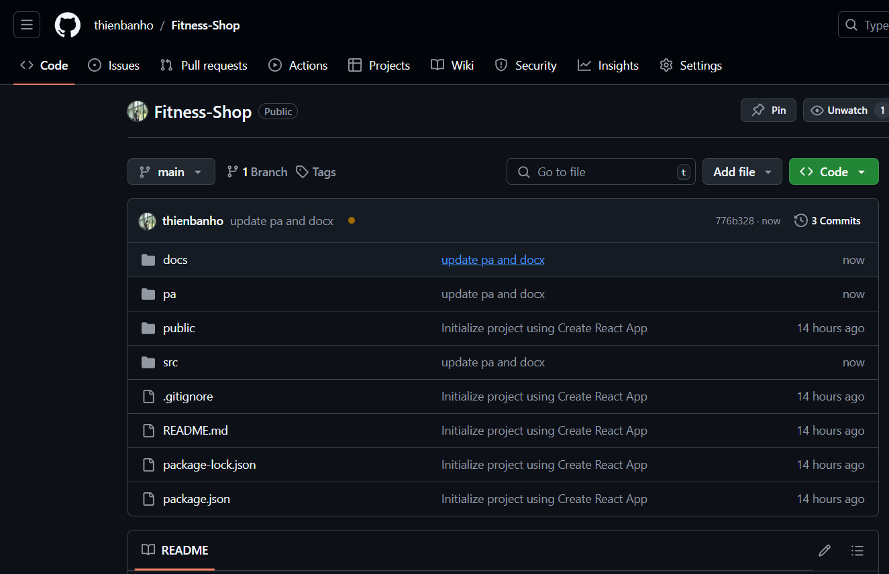

**Discord** for discussions and interactions among group members :

<https://discord.gg/TGE2ePVS>

**Slave** for discussions and interactions among group members :

**Google Doc** for writing formal reports and documents

**Jira** for organizing into sprints :

